**Method of Bi-Section:**

This method is based on the following theorem:

If a function $f(x)$ be continuous between x = a and x = b and $f(a)$ and $f(b)$ are of opposite signs, then there exists atleast one root of $f(x)$ between ‘a’ and ‘b’.

Now let $f(a)$ be negative and $f(b)$ be positive. The the root lies between ‘a’ and ‘b’. Let its approximate value be $x_{0}=\frac{1}{2}\left(a+b\right)$. If $f\left(x_{0}\right)=0$, we conclude that $x_{0}$ is a root of $f\left(x\right)$. Otherwise,

|  |  |
| --- | --- |
| the root lies between $x_{0}$ and b or between $x_{0}$ and a depending on whether $f\left(x_{0}\right)$ is negative or positive. Then we bisect the interval in which the root exists and repeat the process until the root is obtained to the derived accuracy. The geometrical interpretation of the method of | Fig> 2 |

Bisection has been explained with the help of figure.2. By repeating the bisection procedure, the root is enclosed in the search interval and the search interval is halved in each interaction. Ten numbers of iterations reduce the search by $2^{10}≈1000$ times. The iteration cycle is to be stopped as soon as the search interval

Now we are discussing Bi-Section method step by step.

Let f(x) be a continuous function of x. When we plot f(x) vs x, then f(x) may cut x-axis at several points. As shown in the figure, f(x) cut x-axis at two points. At these two points (say $x_{1}$ and $x_{2}$) the value of $f\left(x_{1}\right)=0$ and also $f\left(x_{2}\right)=0$. That is $f(x)$ is an algebric quadratic equation of x.

If $f(x)$ is analgebric equation of x which contains $x^{3}$ term then there are three points on the x-axis (say $x_{1}$, $x_{2}$ and $x_{3}$) where $f(x)$ becomes zero. That is; $f\left(x_{1}\right)=0$, $f\left(x_{2}\right)=0$ and $f\left(x_{3}\right)=0$. The we may say that $f(x)$ has three roots. Similarly if $f\left(x\right)$ is an algebric equation of x ehich contains the maximum power of x as $x^{4}$, then we find four roots of $f(x)$ thaat is $f(x)$ cut x-axis at four points (say $x_{1}$, $x_{2}$, $x_{3}$, $x_{4}$) and so on.

Now Bi-section method is a numericaal method for calculation of all the roots of $f(x)$. Computer porgrramming can be done based on Bi-section method for the calculation of all the roots of $f(x)$ within a given interval (saya and b) on the x-axis.

**Step-wise discussion of Bi-section method for calculation of at least one root of $f(x)$.**

**Step-1:** Consider two points (say a and b) on the x-axis. Hence the interval is in between a and b. This is shown in figure below.

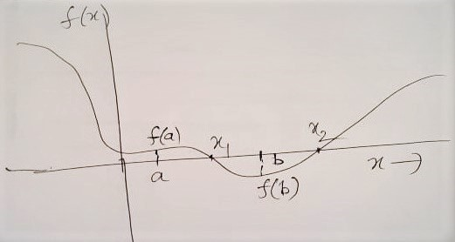

**Step-2:** Find $f\left(a\right)$ and $f(b)$. This can be done by putting the values of a and b in the expression of $f(x)$ one by one.

For example consider the expression of $f(x)$ as;

$$f\left(x\right)=x^{3}-2x^{2}-x+2$$

$$⇒f\left(a\right)=a^{3}-2a^{2}-a+2$$

$$⇒f\left(b\right)=b^{3}-2b^{2}-b+2$$

**Step-3:** Check whether $f\left(a\right)$ or **/** and $f(b)$ is **/** are equal to zero.

If $f\left(a\right)$ or **/** and $f(b)$ is **/** are equal to zero, then $a$ or **/** and $b$ is **/** are the root **/** roots of $f(x)$.

**Step-4:** In case any of them is zero, then we write ‘one root is obtained’ and then write its value.

**Step-5:** If none of them becomes zero, that is $f(a)≠0$ and $f(b)≠0$, then check whether $f(a)$ and $f(b)$ are of opposite sign.

If $f(a)$ and $f(b)$ are of same sign then there are two possibilities;

(i) There may not be any root within the given interval a and b.

(ii) There may be even number of roots (two, four etc) within the given interval.

In such case of same sign of $f\left(a\right)$ and $f(b)$ we have to reduce the interval length between a and b. That is we have give some other values of a and b such that the interval length becocmes smaller and $f(a)$ and $f(b)$ must be opposite sign.



**Step-6:** Now if $f(a)$ and $f(b)$ are of opposite sign, then say $f\left(a\right)→+ve$ and $f\left(b\right)→-ve$

**Step.7:** Now find another point C which is just the middle of a and b, that is; $c=\frac{\left(a+b\right)}{2}$

Now find $f(c)$ and check whether $f(c)<Accu$. Where Accu value is assigned as very small and may be $→0$. If so then c is the solution of $f(x)$.

If $f\left(c\right)>Accu$ then c is not a root of $f(x)$.

Then check the sign of $f(c)$.

**Step.8:** If $f\left(c\right)$ becomes negative then replace the value of b by c that is the value of b = c.

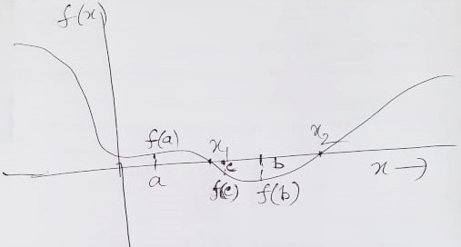

Then again find the value of $f(b)$ with the new value of b.

On the other hand if If $f\left(c\right)$ becomes positive then replace the value of a by c that is the value of a = c.

Then again find the value of $f(a)$ with the new value of a.

Step.9: Then again find the value of c with the new value of a or b. The continue this process of step-7 and step-8 by folloiwng a Loop until at last you will find that $f\left(c\right)<Accu$. That is c becomes a root of $f(x)$.

**Conclusion:** Following these steps you have to develop the program to find at least one root of an algebric polynmial equation.

**Note:** To find all the roots of the algebric polynomial, you have to choose a large interval say $a_{1}=-10$ and $b_{1}=+10$. Then you have to create a large number of segments within this interval using a outer loop. Say you create 100 segments.

First segment is $a_{1}=a=-10$ and $b=-10+0.1=-9.9$

Then within this interval of $a=-10$ and $b=-9.9$ run the inner loop to check whether there is any root.

The consider the second segment namely;

$a=-9.9$ and $b=-9.9+0.1=-9.8$

Then within this interval of $a=-9.9$ and $b=-9.8$ run the inner loop to check whether there is any root.

Continue this for all the 100 segments using the outer Loop and then run in the inner Loop. Then you will find the roots.

You may also increase or decrease the interval by giving the values of $a_{1}$ and $b_{1}$ from the input using Read(*,*) command.

**Program in Fortran on Bi-Section Method to find one root of an equation.**

C bisec1.f

C This program solves the equation

C 2*(x**3) + 3*(x**2) - 4*x + 1 = 0

C and find **one root** of the equation

C Using the Numerical Method of Bisection Method

! Start of the program

Real acc, fa, fb, fc, a, b, c

Write(*,*) ‘Give the value of accuracy’

Read(*,*) acc

1 Write(*,*) ‘Give values of the Interval limits a and b’

Read(*,*) a, b

fa=2*(a**3) + 3*(a**2) - 4*a + 1

fb = 2*(b**3) + 3*(b**2) - 4*b + 1

If (fa.Lt.acc) then

Write(*,*) ‘one root of the equation is’, fa

Goto 3

endif

If (fb.Lt.acc) then

Write(*,*) ‘one root of the equation is’, fb

Goto 3

Endif

If (sgn(fa).eq.sgn(fb)) then

Write(*,*) ‘give new values of fa and fb’

Goto 1

Endif

2 c=(a+b)/2

fc=2*(c**3) + 3*(c**2) - 4*c + 1

If (fc.LT.acc) then

Write(*,*) ‘one root of the equation is’, fc

Goto 3

Endif

If (sgn(fa).eq.sgn(fc)) then

fa=fc

goto 2

else

b=c

fb=fc

goto 2

endif

3 stop

end

-----------------------------------------------------------

**Write the program of Bi-Section method of solution of an equation considering a large number of segments within the interval to find all the roots of the equation.**

**Program in Fortran on Bi-Section Method to find all the roots of an equation.**

C bisec2.f

C This program solves the equation

C 2*(x**3) + 3*(x**2) - 4*x + 1 = 0

C and find **all the roots** of the equation

C Using the Numerical Method of Bisection Method

! Start of the program

Real acc, a1, b1, a, b, c, fa, fb, fc, k

Integer i, j

Write(*,*) ‘Give the value of accuracy’

Read(*,*) acc

1 Write(*,*) ‘Give values of the Interval limits a1 and b1’

Read(*,*) a1, b1

k=(b1-a1)/100

j=0

2 a=a1+j

b=a+k

j=j+k

if (k.GT.(b1-a1)) then

goto 4

else

k = k+(b1-a1)/100

fa = 2*(a**3) + 3*(a**2) - 4*a + 1

fb = 2*(b**3) + 3*(b**2) - 4*b + 1

If (fa.Lt.acc) then

Write(*,*) ‘one root of the equation is’, fa

Goto 2

endif

If (fb.Lt.acc) then

Write(*,*) ‘one root of the equation is’, fb

Goto 2

Endif

If (sgn(fa).eq.sgn(fb)) then

Write(*,*) ‘give new values of fa and fb’

Goto 1

Endif

3 c=(a+b)/2

fc=2*(c**3) + 3*(c**2) - 4*c + 1

If (fc.LT.acc) then

Write(*,*) ‘one root of the equation is’, fc

Goto 4

Endif

If (sgn(fa).eq.sgn(fc)) then

fa=fc

goto 3

else

b=c

fb=fc

goto 3

endif

4 stop

end

-----------------------------------------------------------

116 complete

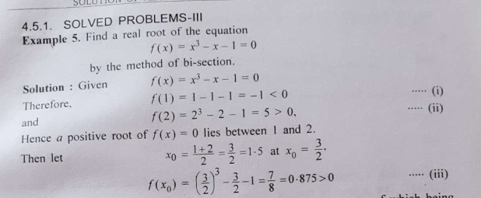

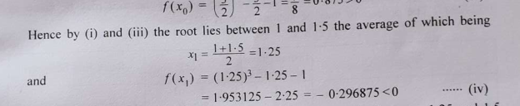

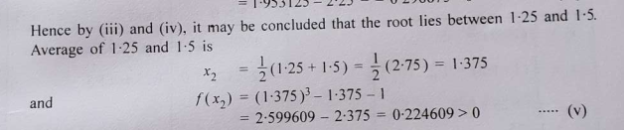

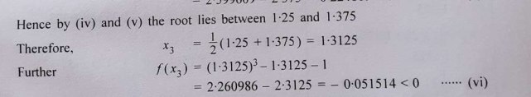

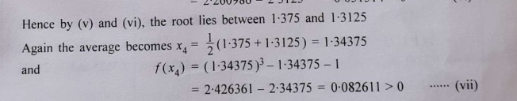

Hence by (vi) and (vii), te root must lie between 1.3125 and 1.34375.

Further $x_{5}= \frac{1}{2}\left(1.3125+1.3475\right)=1.328125$

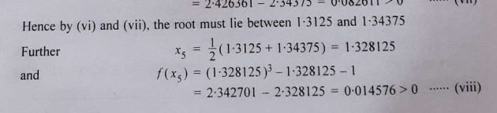

Page 117 complete